Using Axia IP-Audio Driver to stream audio between two PC systems

2004-11-22 Maciej Szlapka (maciej@axiaaudio.com) Axia/Telos Systems

Important notes:

It is assumed that you have basic knowledge about Livewire system. This document does not provide all the information required to understand this topic. Please see “Introduction to Livewire”, available for download on: http://www.axiaaudio.com/downloads/default.htm

Axia IP-Audio Driver supports Microsoft Windows 2000 Pro and Microsoft Windows XP Pro platforms.

Streaming audio involves significant amount of network traffic. Be careful when planning your network connectivity.

Introduction

The driver is designed to be a part of Livewire network that usually contains hardware nodes that provide audio interface and universal time base for all Livewire devices, including the Windows driver. Although, it is possible to use the software to reliably stream audio from one PC to another without having any of Axia hardware nodes.

This document describes two different situations where the driver is used. In both examples PC1 sends audio to Livewire streams, and PC2 receives it. It is possible to establish 8 stereo audio channels in each direction (PC1 to PC2, and PC2 to PC1). PC1 and PC2 can be interconnected together using crossover Ethernet cable or through an Ethernet switch designed for high throughput Ethernet multicast.

Both computers have to be in the same IP network. E.g.:
PC1: 192.168.2.150 network mask 255.255.255.0
PC1: 192.168.2.148 network mask 255.255.255.0

It may be convenient to install a separate network card for Livewire network.

In first example PC2 will receive audio from the network and play it directly through a hardware sound card.

In second example, PC2 will record the audio.

Installation

Axia IP-Audio driver is distributed as Microsoft Windows Installer package. During installation you will be prompted to do some installation choices and accept license agreement.

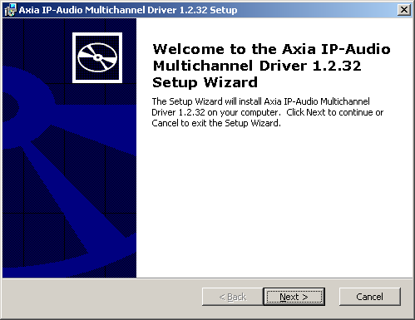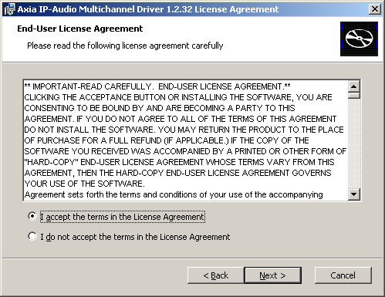

Use “Typical” installation. You will need a license key and code provided by Telos.

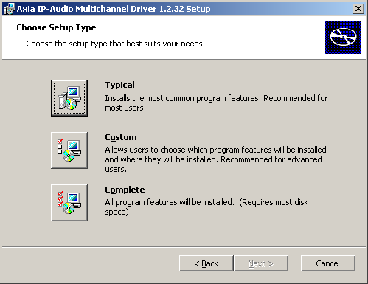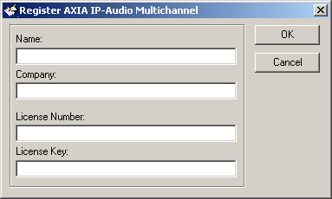

At the end of the installation process, a configuration window will pop up. You can go back to change settings of the driver by using Control Panel.

Configuration

Examples below show how to configure the driver for PC1 to PC2 bi-directional streaming.

Logical audio connections are presented below:
WAVE OUT 1
WAVE OUT 2
WAVE OUT 3
WAVE OUT 4
WAVE OUT 5
WAVE OUT 6
WAVE OUT 7
WAVE OUT 8
WAVE IN 1
WAVE IN 2
WAVE IN 3
WAVE IN 4
WAVE IN 5
WAVE IN 6
WAVE IN 7
WAVE IN 8
1000
1010
1020
1030
1040
1050
1060
1070
WAVE OUT 1
WAVE OUT 2
WAVE OUT 3
WAVE OUT 4
WAVE OUT 5
WAVE OUT 6
WAVE OUT 7
WAVE OUT 8
WAVE IN 1
WAVE IN 2
WAVE IN 3
WAVE IN 4
WAVE IN 5
WAVE IN 6
WAVE IN 7
WAVE IN 8
2000
2010
2020
2030
2040
2050
2060
2070
PC1
PC2
PC2
PC1

Numbers over arrows show Livewire channel numbers.

PC1 sends audio to channels:
2000, 2010, 2020, 2030, 2040, 2050, 2060, 2070
PC1 receives audio from channels:
1000, 1010, 1020, 1030, 1040, 1050, 1060, 1070
PC1 sends audio to channels:
1000, 1010, 1020, 1030, 1040, 1050, 1060, 1070
PC1 receives audio from channels:
2000, 2010, 2020, 2030, 2040, 2050, 2060, 2070

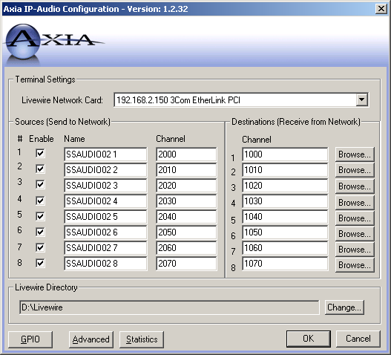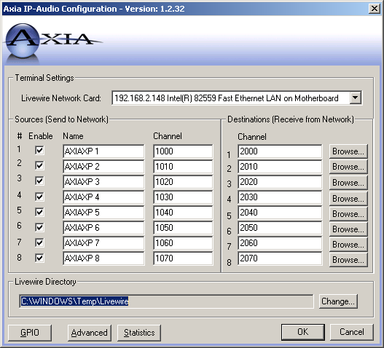

The driver starts sending network packets as soon as a player application starts playing audio on one of Axia wave-out devices.

Streaming audio

Any application using the WAVE interface can be used. Examples below show how to start streaming audio using popular Winamp:

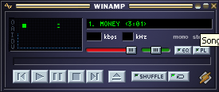

Make sure that you selected one of “Axia IP-Audio out” devices for playback in Winamp (or player of your choice) preferences:

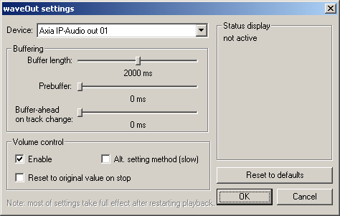

If you started the playback on PC1, you can record or receive audio from Livewire stream on PC2.

It is possible to start playback on multiple (up to 8) Livewire channels at the same time. This can be done by running multiple instances of the playback application, or by using more sophisticated automation system.

Example 1: Playing audio from Livewire channel

On PC2, you can use “Livewire Selector” to listen/monitor audio generated by PC1. “Livewire Selector” comes with Axia IP-Audio Driver and can be run from Start -> Program Files -> Axia.

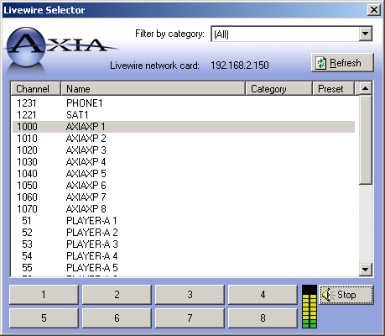

The application automatically discovers Livewire channels available in the network. Select an channel sourced by PC1, and hit Play. Audio playback will start. If your default audio playback device is a sound card in PC2, you will hear the audio.

Livewire Selector uses Microsoft audio architecture that will build a rendering chain containing sample rate converter that is needed in this application to compensate for clock differences between PC1 (audio source) and the hardware sound card in PC2 (rendering device).

Example 2: Recording audio from Livewire channel

In this example, I show how to use Windows Sound Recorder to record audio streamed by PC1.

Windows Recorder uses preferred recording device, which can be selected using Control Panel -> Sounds and Multimedia window:

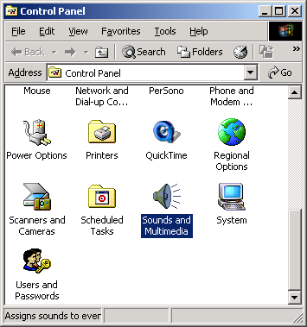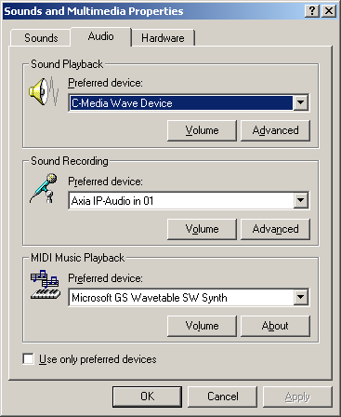

For best audio quality select 48kHz, 16-bit, STEREO audio format for recording.

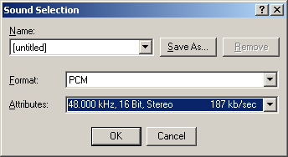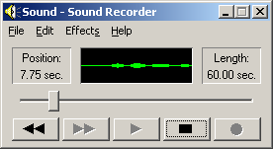

In example above, no sample rate conversion is necessary, as the recorder receives data at the speed of PC1 that generates it.

