Below I am reporting problems with LAN2 interface at X11 SSV-Q under factory warranty
Purchase date 2026-03-12, invoice Faktura końcowa FV-ZAL 12/3/202, FV-ZAL 41/2/2026
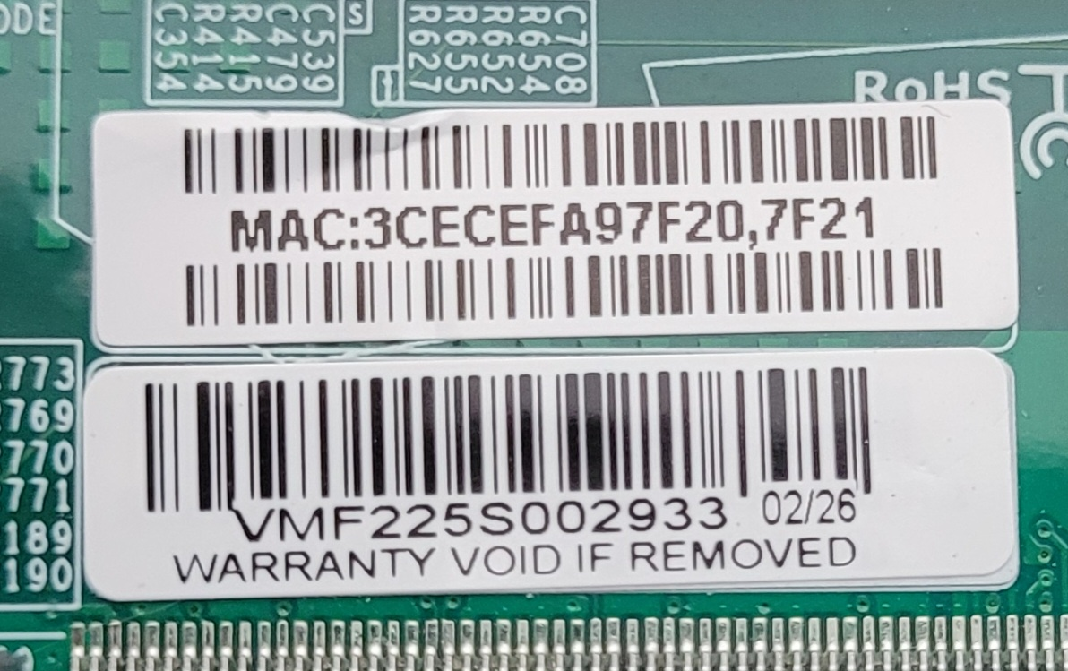Board Serial numer

Both LAN interfaces connected to CISCO Catalyst C-1000, both CISCO ports configured similiarly.
Problems with LAN2 interface – none system can recognize its presence
Tried at Windows and Linux Tumbleweed (both installations well known to me).
ONLY LAN1 is being recognized by any System, and is being configured properly.

My further tests
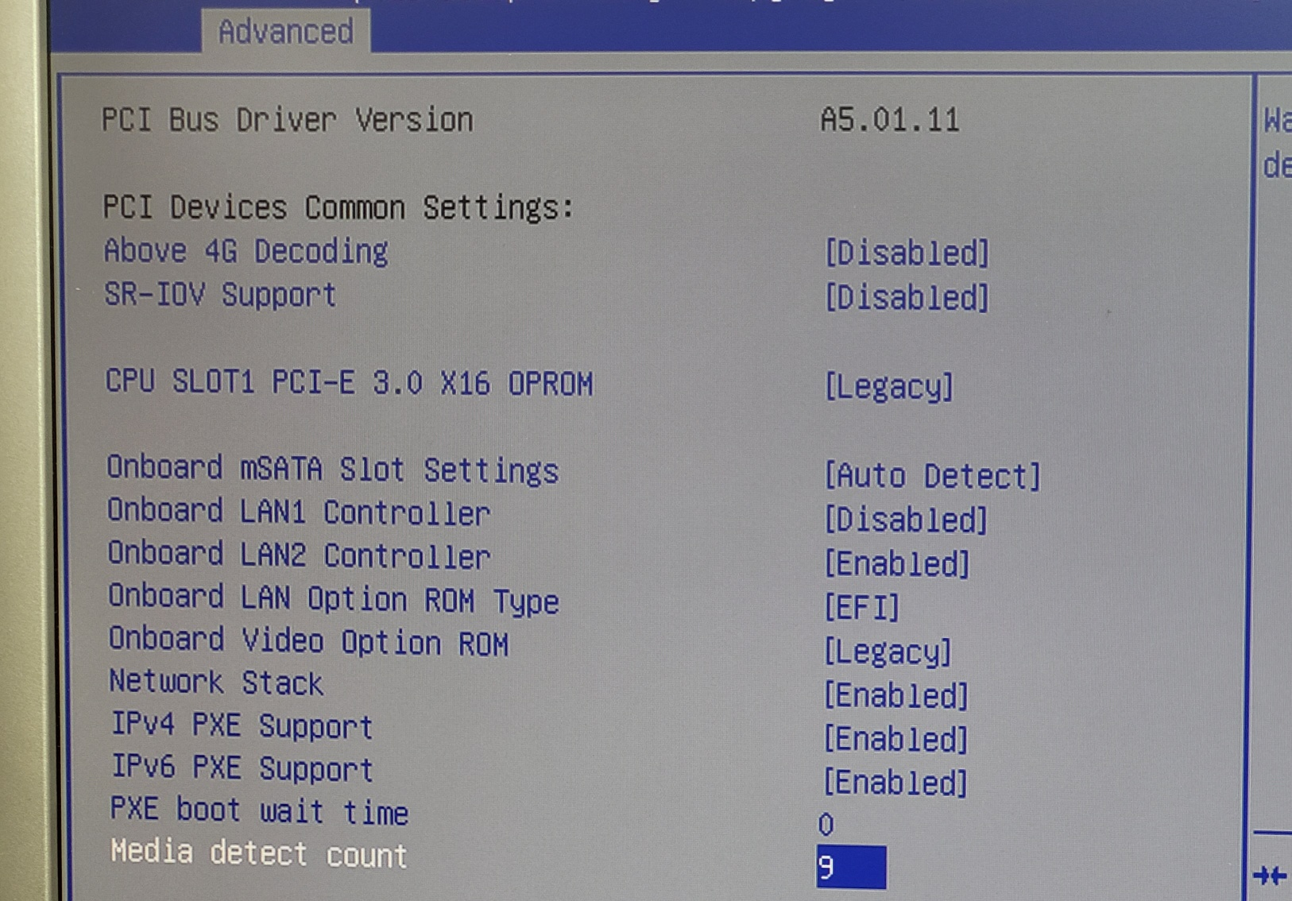For better tests I had only LAN2 physically connected, enabled it in BIOS (while I have LAN1 DISABLED) – see BIOS screenshot

Connected patch cable to LAN1 physical port, and this is operating system response – NO ETH INTERFACE recognized
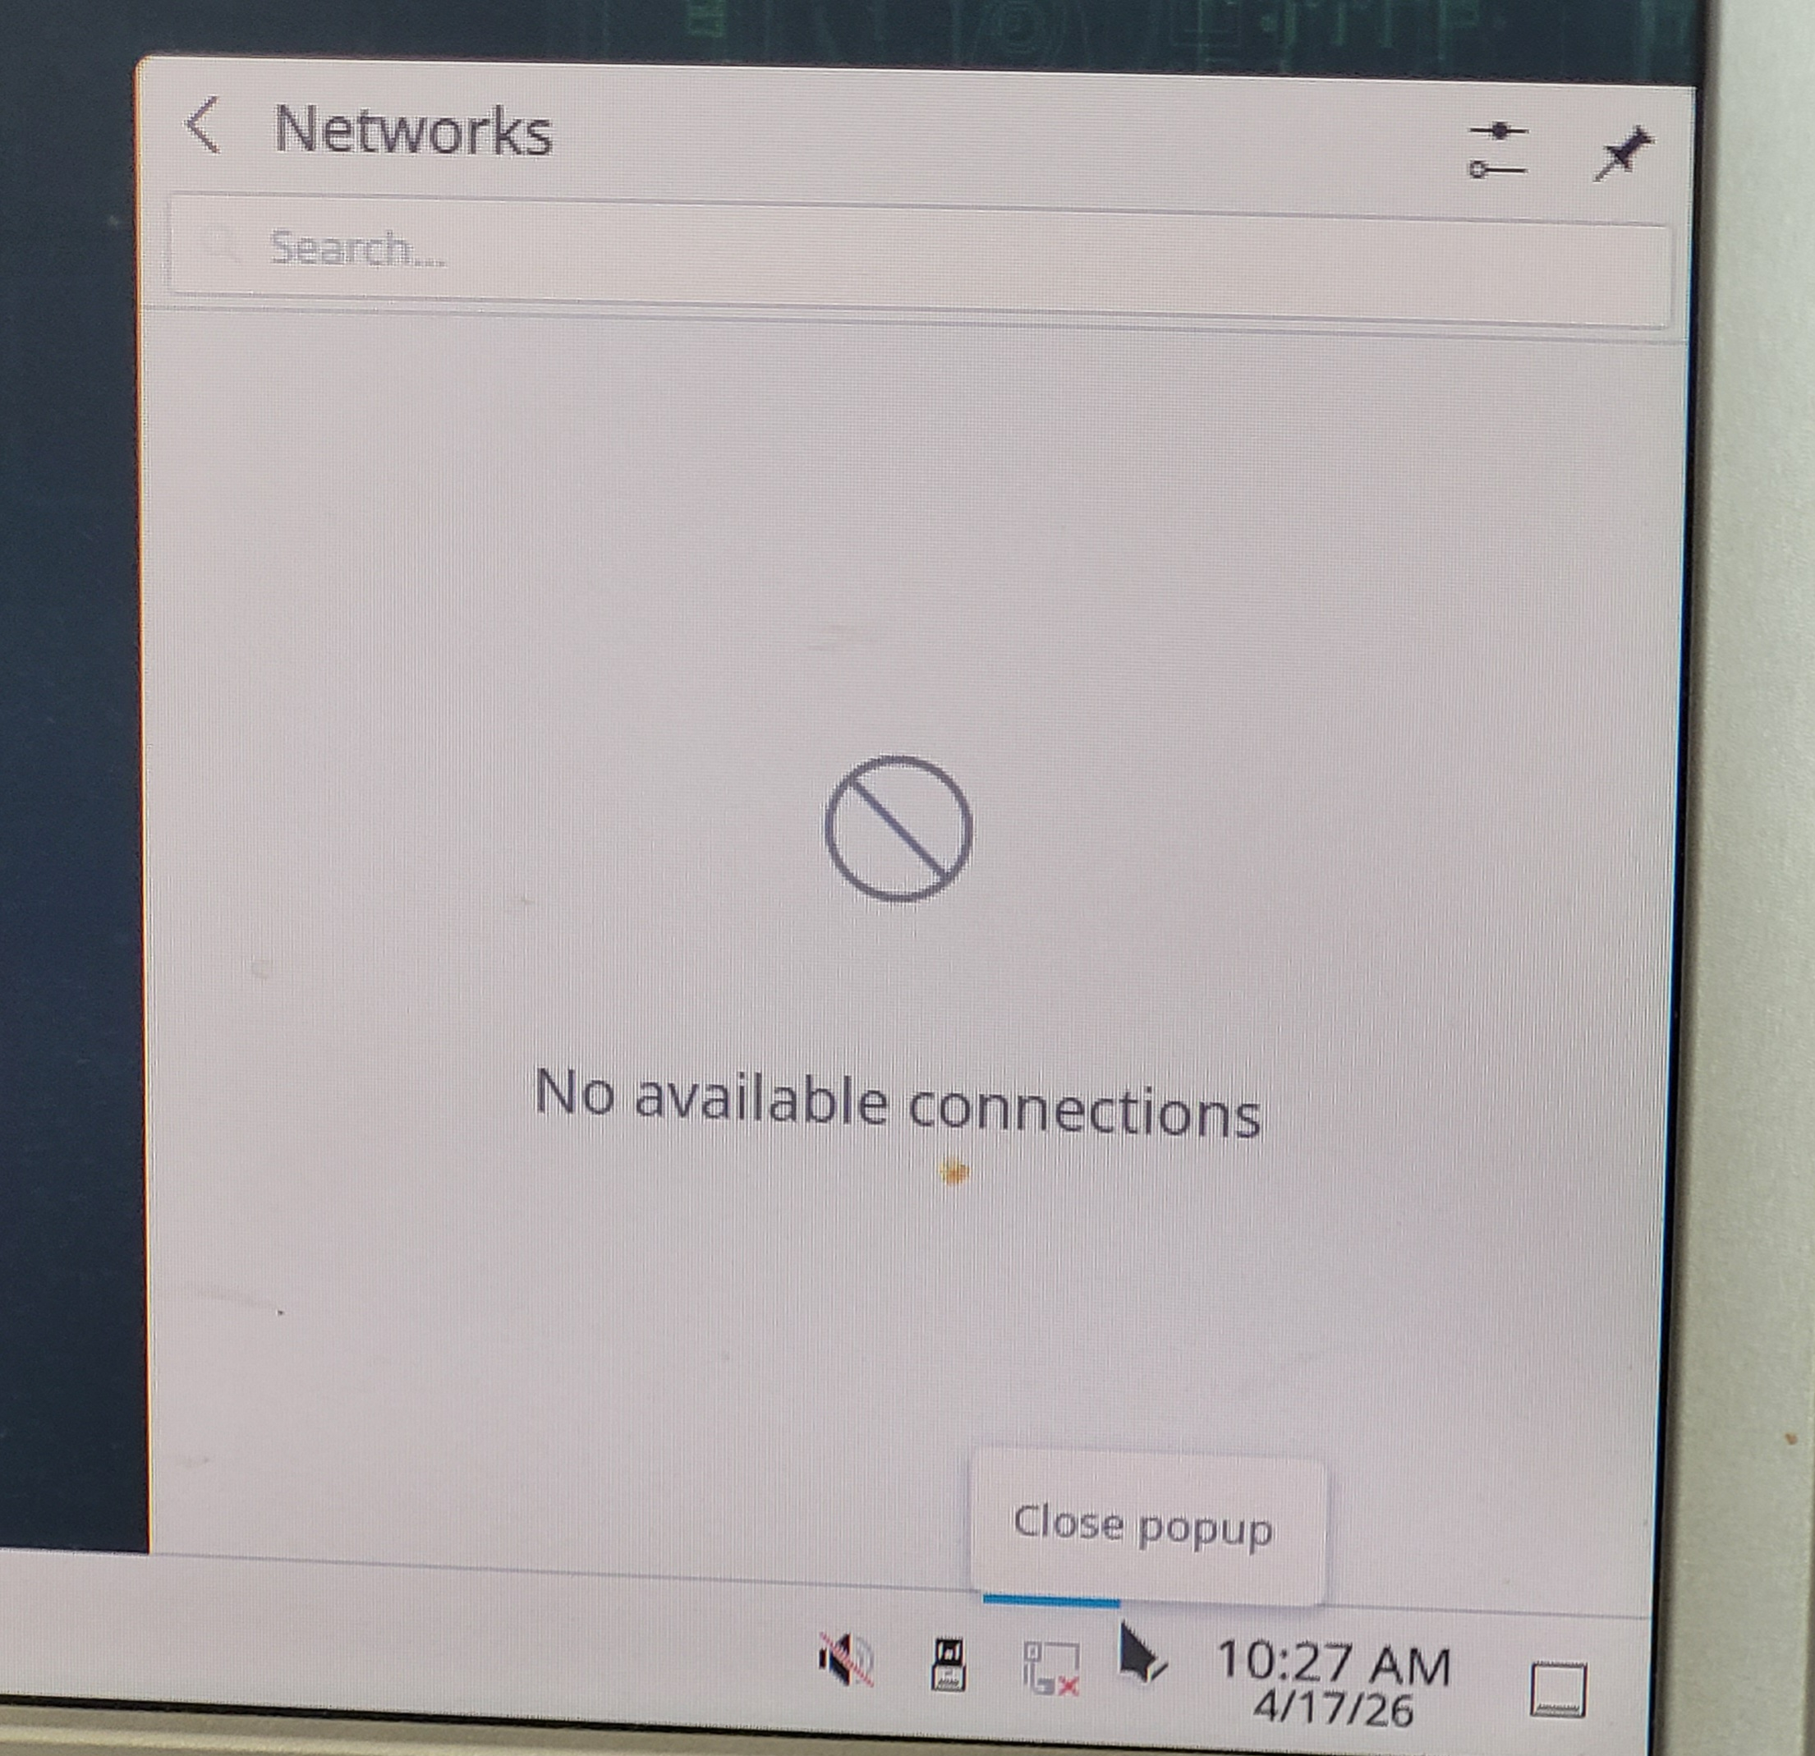

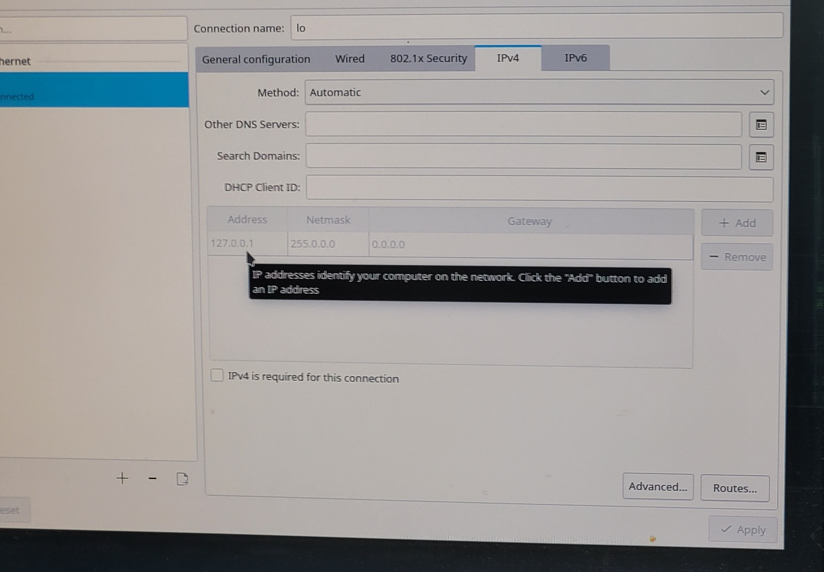

Later I enabled both LAN1 and LAN2 in BIOS
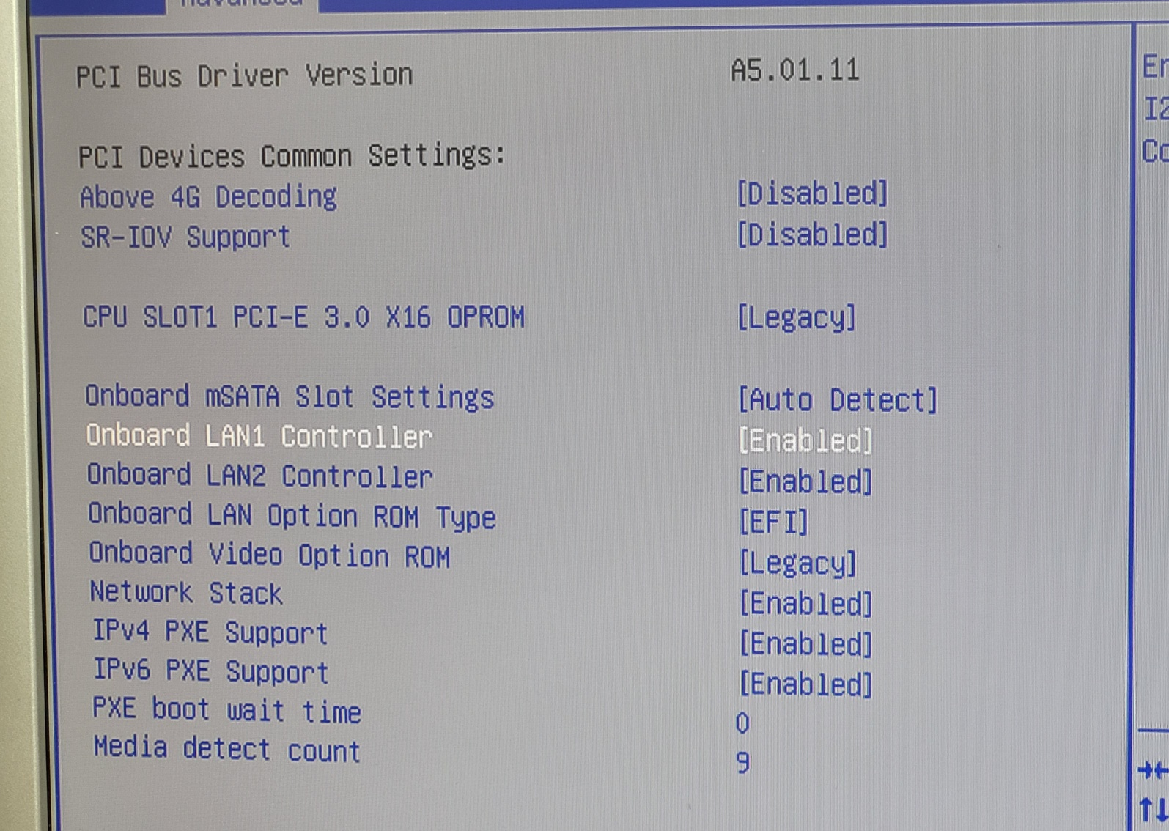
Connected patch cable to physical ports LAN1 and LAN2 and then of course get proper repsonse for LAN1:
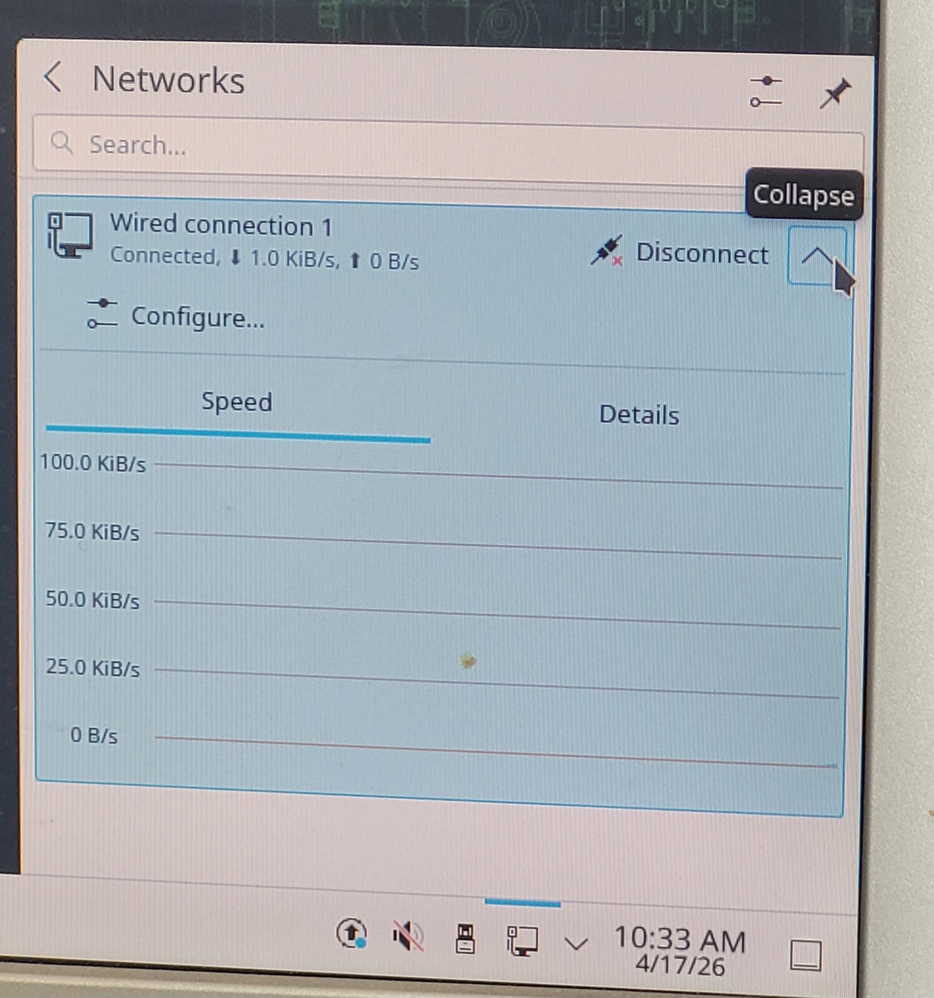

Tried to swap cables, no better, swapped connection to Cisco ports, no better
Made more observations connectind two LES to JF1 header proper pins
When patch cable are connected, LEDs by RJ-45 connectors blink at both physical RJ-45 ports, LAN1 and LAN2, however LED connected to jumper-control ports at JF1 header behave defferently – I mean hear NIC1 Activity LED and NIC2 Activity LED.
When I connect physically patch cable to both ports, both NIC1 Activity LED and NIC2 Activity LED go up appropiately. Later at NIC1 Activity LED one can observe network activity, however the other LED - NIC2 Activity LED stays all time ON – no blinking.
Disconnecting and reconnecting patch cable brings exactly the same result – there is no traffic at ETH2.
BIOS settings for Ethernet interaces have no meaning – tried both enabled/disabled (of course always saved before exiting BIOS by F4 function key) – none system can see LAN2, only LAn1 is recognize as present, at Linux it is called eno1.
Seems for ETH2 we get only Layer1 negotiaiont copmpleted, and no more traffic runs.
In SuperMicro printed materials LAN1 is announced as i210AT, while LAN2 is announced as i219LM

